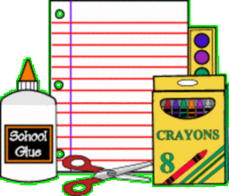

**Face Masks (Disposable or Reusable)**

**Headphones**

**1- Pencil Pouch w/Zipper**

**2- No. 2 Sharpened Pencils 24ct/Box**

**2- Big Erasers**

**2- Boxes of Crayons 24ct.**

**2- Packs of Dry Erase Markers 4pk**

**1- Box Crayola Watercolor Paint**

**1- Pair of Blunt Tip Scissors**

**1- Bottle of Glue**

**12- Glue Sticks**

**2- Wide Rule Spiral Notebooks**

**1- Wide Rule Composition Book**

**6- 2-Pocket Folders**

**(2 red. 2 yellow & 2 orange)**

**2- Boxes 1 Gallon Ziploc Bags**

**1- Box Sandwich Size Ziploc Bags**

**4- Boxes of Kleenex**

**2- Pocket Size Kleenex**

**4- Rolls of Paper Towels**

**2- Clorox Disinfectant Wipes**

**2- Baby Wipes**

**3- Bottles of Hand Sanitizers**

**1- Bottle of Liquid Soap**

**1- Book bag (no wheels)**

**1- Pair of Gym Shoes**

**(To be left at school.)**